User interface of program

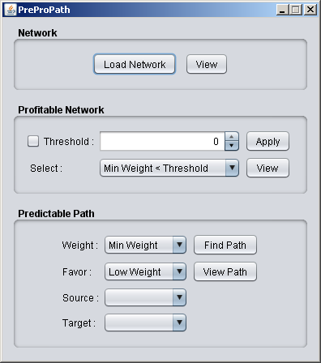

Network

Load Network
It is used to load a network. A graph wizard will open that can load the graph from an excel file.

View
It is used to view the loaded network. When this button is pressed a graph view dialog is opened.

Profitable Network

Threshold
When checkbox is selected threshold is applied to the loaded graph. The threshold value can be entered in the threshold field.

Select
The selected option is used to select the edges in the graph if threshold is enabled.

Apply
When “Apply” button is pressed threshold is applied to the original graph and a new graph is built having edges that satisfy the criteria defined in select dropdown list.

View
It is used to view the graph after applying threshold. If threshold is not enabled the displayed graph is equal to the original graph. When this button is pressed a graph view dialog is opened.

Predictable Path

Weight
It is used to select the weights of edges. These weights are applied to the graph obtained after threshold operation.

Favor
This option selects the favoring criteria.

Source
It is used to select the source node to find favored path. When a graph is loaded and threshold is applied, the dropdown list automatically populated with all the nodes in the graph.

Target
It is used to select the destination node to find favored path. When a graph is loaded and threshold is applied, the dropdown list automatically populated with all the nodes in the graph.

Find Path
When “Find Path” button is pressed, Favored Path Algorithm is run on the graph, which is obtained after threshold, using weights and favoring criteria.

View Path
It is used to view the favored path. When this button is pressed a graph view dialog is opened. The edges are listed in the order they were added to the graph.

Graph Wizard

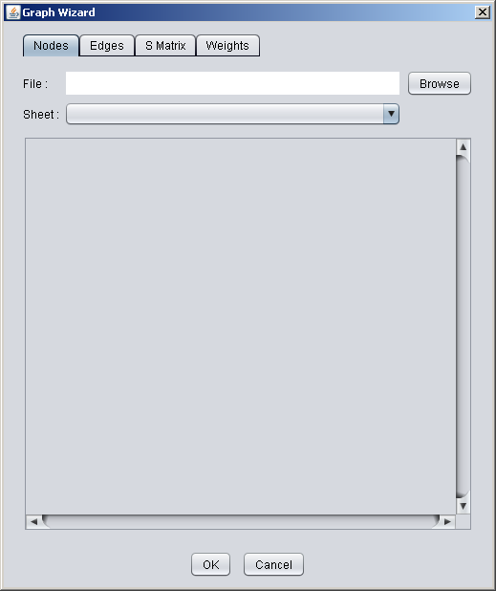

Nodes

File
Displays the path of selected excel file.

Browse
It is used to select the excel file using a file open dialog. When it is pressed the last opened file is selected by default.

Sheet
It is used to select a sheet in the excel workbook. When a sheet is selected the contents of the sheet are displayed in the table.

Node Selection
The contents of cells can be modified by double clicking the cell. This modification is applied to loaded data only without changing the original excel file.
For nodes two columns must be selected. First column should be names of nodes and second column should tell whether the node is a cofactor. A value ‘0’ is used to specify a normal node and a value ‘1’ is used for cofactor.
The order of columns can be changed by dragging the column title.

Edges
Select the row containing the edge names.

S Matrix
Select the stoichiometric matrix for the network. All the edges are treated as irreversible. For reverse edges please add another column with opposite signs as that of the forward edges.

Weights
Select two columns representing the min and max value of the edge weights.

